OFFICIAL COORDINATION REQUEST FOR
NON-ROUTINE OPERATIONS AND MAINTENANCE

COORDINATION TITLE: 13BON B2CC hydrofoil PIT detector test
COORDINATION DATE-14 March 2013
PROJECT- Bonneville Dam
RESPONSE DATE- 14 March (FPOM)

Description of the problem: The corner collector at the 2nd Powerhouse of Bonneville Dam (B2CC) is an ideal location to field test the proof of concept for a full size hydrofoil PIT-tag system due to existing infrastructure, ease of installation, and cost savings. The B2CC provides existing PIT-tag detection that would enable assessment of the PIT-tag detection efficiency of a hydrofoil PIT-tag detection system. Other surface passage facilities in the Federal Columbia River Power System (FCRPS) lack PIT-tag detection that could be used to assess the detection efficiency a hydrofoil PIT-tag detection system. Furthermore, the entrance width of the B2CC is 15 feet wide and the entrance to other surface passage structures is 50 feet wide. A smaller width surface passage test environment simplifies the approach and reduces the cost of evaluating the proof of concept prototype. A system that provides coverage for the of the B2CC would only require approximately 4 hydrofoil antennas where as a system for other surface passage structures such as a Removable Spillway Weir (RSW) would require 18 hydrofoil antennas to provide a similar level of coverage because the width of the entrance is larger. Significant cost savings would result in developing and testing the hydrofoil PIT-tag system concept at B2CC compared to other surface passage structures. If the prototype performs well, the concept may be used to develop PIT-tag detection for surface passage structures or the The Dalles Dam ice and trash sluice way.

Type of outage required: Three periods of change in operation of the B2CC are requested, two 8-hour outages and one 8-hour operation in September.

Closure of the B2CC would be required for installation of monitoring equipment (DIDSON camera or hydroacoustic) to evaluate passage distribution into B2CC (Figure 1). It is expected that the install of monitoring equipment will require 4 to 8 hours and occur in July, 2013.

A second closure of the B2CC would be required for installation of the prototype forebay PIT-tag monitoring system. It is expected that the install of monitoring equipment will require up to 8 hours and occur approximately 1 week after the earlier outage in July, 2013.

Run B2CC during the 1st week of September to test debris response of hydrofoil antennas.

Table 1. Tentative changes in the Fish Passage Plan required for the project.
Dates | Outage | Activity
early July | 8 hours outage | Install monitoring equipment (i.e. DIDSON camera or hydroacoustic equipment)
July 22-26 | 8 hours outage | Install a prototype forebay PIT-tag detection system for detection of PIT-tagged fish entering the B2CC.
Sept. 1-7 | 8 hour operation | Test debris response of hydrofoil antennas.

Impact on facility operation: The installation of monitoring equipment and closure of the B2CC will require operational support from the project. Project crane assistance for the installation and removal of monitoring equipment and the prototype forebay PIT-tag detection system will be coordinated with the project. Access to the intake area of the B2CC will be needed by the contractor on a regular basis between June and September 2013. Outages during equipment install will be required. Table 2 is a tentative schedule for the study.

Table 2. Tentative project schedule.
Dates | Activity
June-July | Install monitoring equipment
 | (DIDSON camera or hydroacoustic equipment)
July 16-22 | Evaluate the B2CC passage distribution before installation of the prototype forebay PIT-tag detection system.
July 22-26 | Install a prototype forebay PIT-tag detection system B2CC entrance.
July 27-Aug. 31 | Evaluate the physical performance of the prototype forebay PIT-tag detection system.
July 27-Aug. 31 | Evaluate the B2CC passage distribution with prototype forebay PIT-tag detection system installed.
Sept. 1-7 | Test debris response of hydrofoil antennas.
Sept. 7-15 | Remove monitoring equipment and prototype forebay PIT-tag detection system.

Length of time for repairs: N/A

Expected impacts on fish passage: Installing equipment will occur during the fish passage season. Removal of equipment will occur at the end of the season and should not affect fish passage.

B2CC outages will temporarily increase the number of fish passing through turbines and the juvenile bypass system and may affect smolt survival. Estimates of the potential impact to migrating yearling Chinook salmon, coho salmon, sockeye salmon and steelhead smolts have been generated (See Tables 3 and 4).

The additional operation of the B2CC for debris testing (not more than 1 week) in September is not anticipated to negatively impact fish passage.

There is no anticipated impact to other studies at Bonneville Dam in July and August 2013.

Affects of two 8-h outages of B2CC in July:
Each outage would be up to 8 hours. A contract is in process for this study so the actual timing for the outage of B2CC to install equipment has not been determined, however, the outage and equipment installation would be sometime in July 2013. The overall impact to ESA listed stocks was estimated by applying the passage proportions and survival estimates from the Compass Model to the daily 5-year average smolt passage index (from Fish Passage Center). The impact to the percent and number of ESA listed fish from two 8hour outage of the B2CC was estimated using the NOAA Fisheries 2012 “Estimation of Percentages for Listed Pacific Salmon and Steelhead Smolts Arriving at Various Locations in the Columbia River Basin”. Assumptions used for assessing the impact included: 1) passage distribution is similar across the day and the 16-hour outage represented 2/3 of the daily passage numbers, and 2) Compass Model passage distribution and survival for Coho and sockeye salmon was assumed to be the same as yearling Chinook salmon. Compass Model estimates and calculated assumptions are presented in Table 1. Numbers of additional mortality (overall and ESA listed fish) from a two 8-hour closures of the B2CC in July is presented in Table 2.

Table 3. Compass Model and calculated assumptions by species of closing the B2CC for up to 16-hours (two 8-hour periods) in July.
 | subyearling Chinook | Yearling Chinook | Coho | Sockeye | Steelhead
Compass B2CC passage | 22.4% | 18.7% | 18.7% | 18.7% | 42.0%
Compass % change in survival/24 hours | -4.7% | -1.3% | -1.3% | -1.3% | -0.9%
% ESA listed | 37.7% | 15.5% | 1.5% | 0.9% | 72.4%
Change in ESA listed survival/24 hours | -1.78% | -0.21% | -0.02% | -0.01% | -0.64%

Table 4. Estimated additional mortality resulting from closing the B2CC for 16-hours (two 8-hour periods) in July.
 | subyearling Chinook | Yearling Chinook | Coho | Sockeye | Steelhead
B2CC passage/day in July  (5-year average) | 3,368 to 22,942 | 0 to 88 | 0 to 98 | 0 to 135 | 40 to 272
Estimated additional mortality | 106 to 722 | 0 to 1 | 0 to 1 | 0 to 1 | 0 to 1
Estimated additional mortality  (ESA listed) | 40 to 272 | 0 | 0 | 0 | 0 to 1

Comments from agencies
14 March 2013 FPOM- 13BON05 B2CC hydrofoil PIT detector test. (attached). Laughery provided a .ppt presentation. Installation will require the B2CC be closed for two days. Laughery is looking at an ERDC trip in April to look at the TSW model. Sands submitted a request for access request letter to BON. NWW is waiting on approval from BON before going forward with the contracting to start fabrication and installation. Fredricks said there is the coordination that is occurring today and then further coordination regarding details about timing and deployment. Hausmann said the BON concerns are primarily debris and the impact to the slot filler. Currently there is not a good way to free debris since it is very rare that anything gets hung up at the B2CC. CRITFC is ok with the installation as long as it doesn’t significantly impact B2CC operations. Hevlin thanks Fredricks for working out the bugs on this project in NWP rather than at LWG. Fredricks said he figured it would impact less fish at the B2CC than at a TSW at LWG. Fredricks also noted that this test is scheduled for a time when sub-yearlings pass and sub-yearlings do not use the B2CC as much as the spring fish. There will not be any additional fish tagged to pass through this system. FPOM is in agreement with moving this test forward

Final results: As far as FPOM, this test may go forward as coordinated. The next step is getting the approval letter from BON.

Figure 1. Equipment barge for monitoring B2CC passage using DIDSON camera or hydroacoustic.
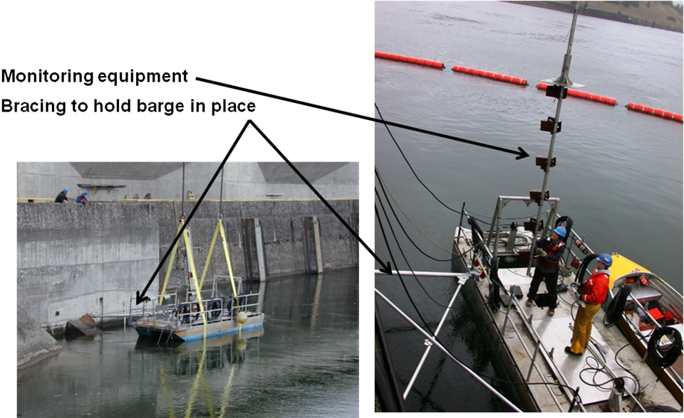
Figure 2. Plan view of hydrofoils and frame mounted to B2CC slot filler.
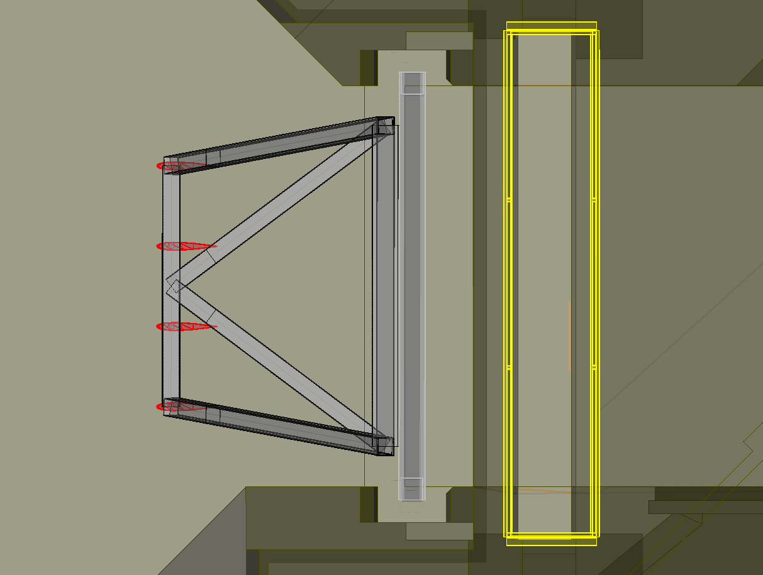
New Support Frame Attached to Slot Fillers

Figure 3. Section view of hydrofoils rotated to B2CC closure gate.
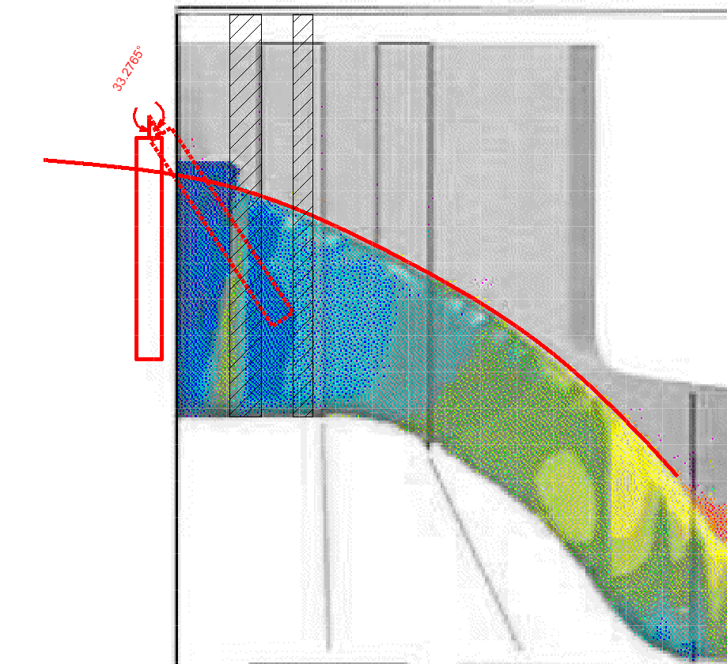
Closure Gate Slot

